Video Editing Instructions - ArcSoft Media Impression for Kodak
Please follow the step-by-step guidelines below to learn all the basic editing features of the Media Impression software.
- Open software and locate your video files in the left hand column.
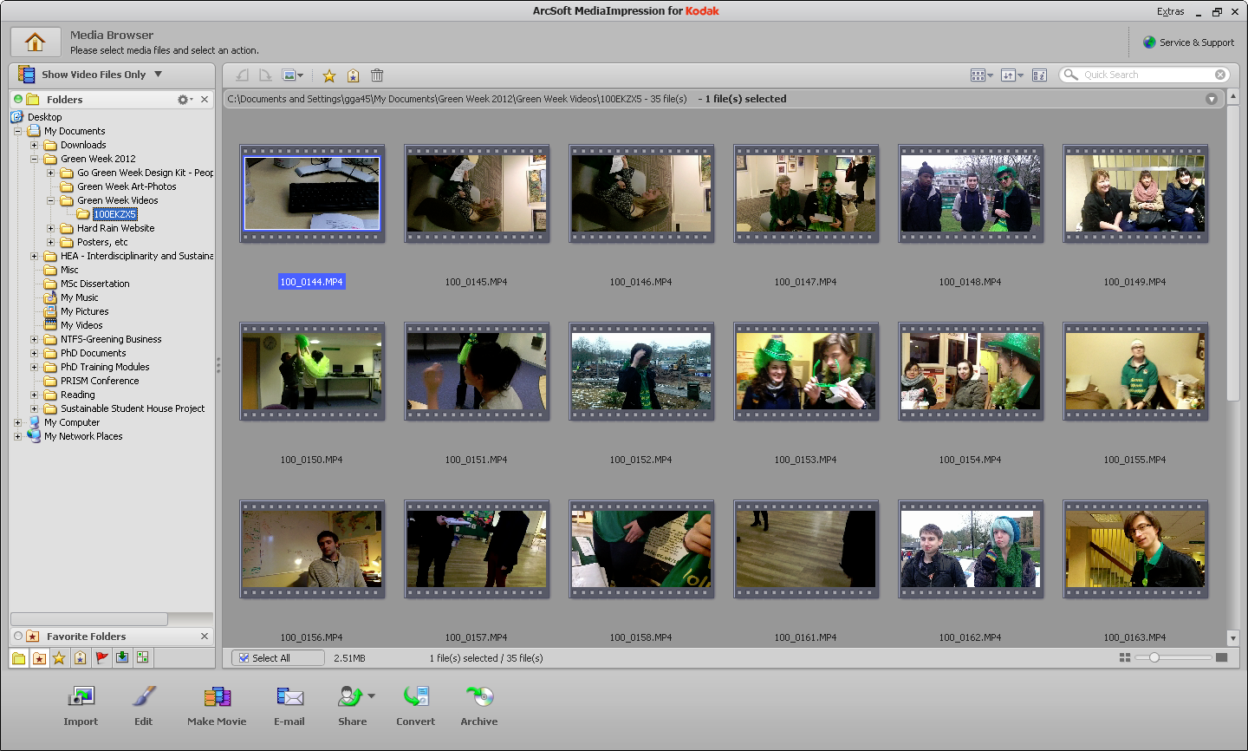

- Select all the files you want to use for your film and click Make Movie to add them to your storyboard.
- To add an individual file to the storyboard, click on it and press ADD. To remove an individual file from your storyboard, click on the green tab on the required file and click Remove.
- To change the order of your video clips in the storyboard, simply drag and drop files into the required place

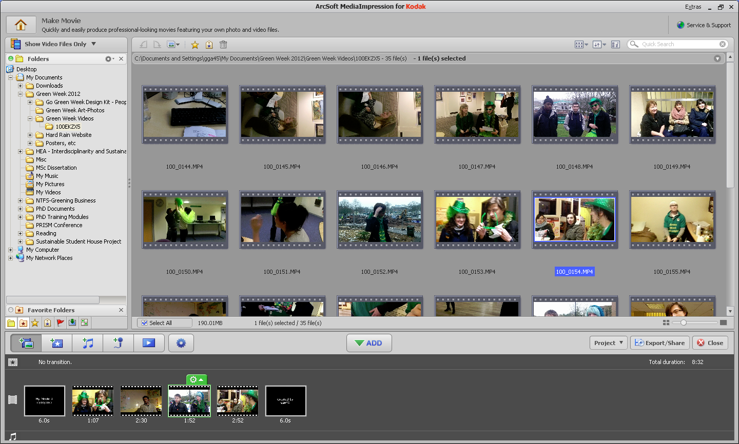
- To edit the length of a video clip or to add effects, click on the green tab on the required file and click Edit. Use the scissor tools to crop video files. Scroll through the Effects tab to see different ways of editing your video clips. Press OK to save changes.
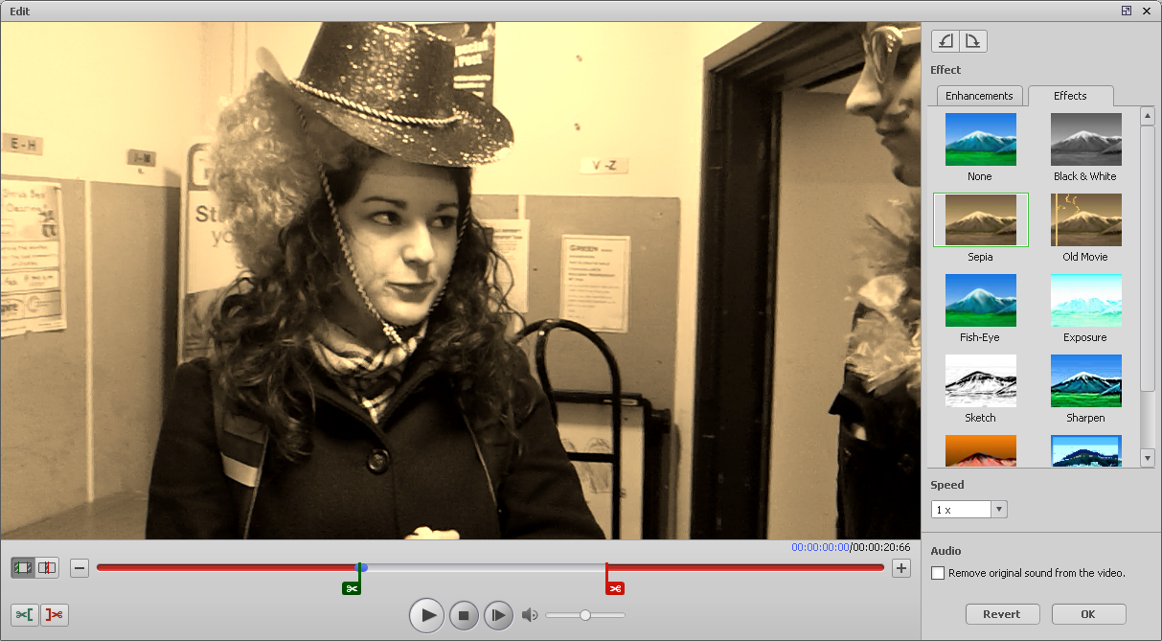

- To add captions to your video clips, click on the green tab again and click Add Caption. Move the cursor at the bottom of the screen to where you want the caption to appear and how long you want it to run. You can change the font, size and colour of the text. You can add multiple captions to one video clip. Click OK to save captions.

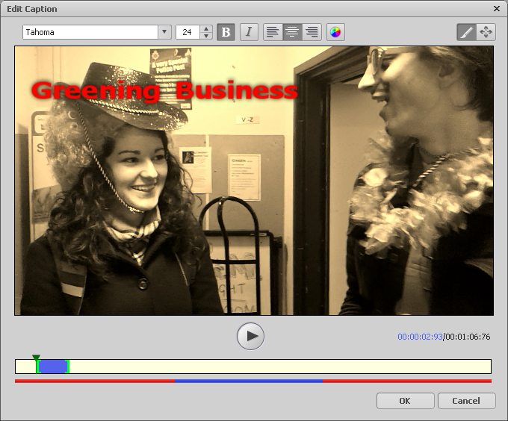

- You can insert text frames before or after any video clips in the sequence. You can choose the length of the text frames and add your own textual information. Click on green tab and then Insert Text Frame Before/After.
- You can add a transition theme between slides by clicking on the Add Transition button (below in red).
- You can also Add Music, Add Voice-over and Preview your film by clicking the other buttons along this menu.
- The Settings button (above in orange) allows you to edit the Title and Credits of your film.
- You can add picture files as stills in-between your video files by locating your pictures in the left hand column and adding them in.
- While you are in the process of editing your videos you should save your video file by clicking Project and then Save As. The film will be saved as an MMP file (Make Movie Project). You can only edit the MMP files in this Kodak software.
- When you are happy that your video is finished, first save it as an MMP file. Then click Export/Share and select the PC option. You can then save your film as an MOV or AVI file. These files will play in any media player. This is the format you should submit your video in. Make sure you have your final video saved as an MMP file too as then you can always go back and edit it if you need to.
Happy film making! If you have any questions or problems please send me an email or come and see me in my office for help
Sophie Bessant: s.e.f.bessant@keele.ac.uk,
01782 – 7 – 34115,
Room 1.35 WS Building

